

AngularJS

Semester: 1 |  | Curriculum Code: 7023
Duration: 90 minutes |  | Total Marks: 20

Practical Examination Paper

Make some AngularJS pages.
Part 1: Say Hello using AngularJS (4 points)
Write a HTML file using AngularJS. This file should:
• Look like the UI below (1 point)
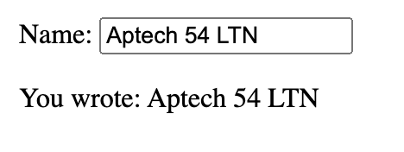
• And when you input a string to input element, the program will response to “You wrote:” (3 points)

Part 2: Write the temperature monitor using AngularJS (6 points)
Write a single page of temperature monitor application using AngularJS. This file should:
- Link to its css and js file (1 point)
- Have the UI like below (1 point)

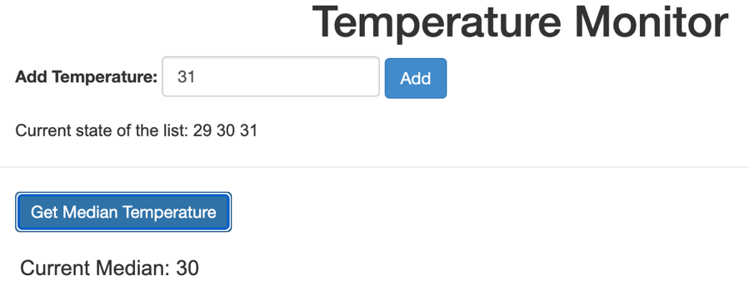

- When user fill a value of temperature to the input “Add Temperature” and click button “Add” or press Enter, the value should append to the current state of the list (1 point)
- When user click button “Get Median Temperature”, it need calculate averate of all temperatures in the list and show the result in Current Median. (3 points)

Part 3: Write the Shopping Cart using AngularJS (10 points)
Write a single page shopping cart application using AngularJS. This file should:
- Link to its css and js file (1 points)
- Have the UI like below (1 points)
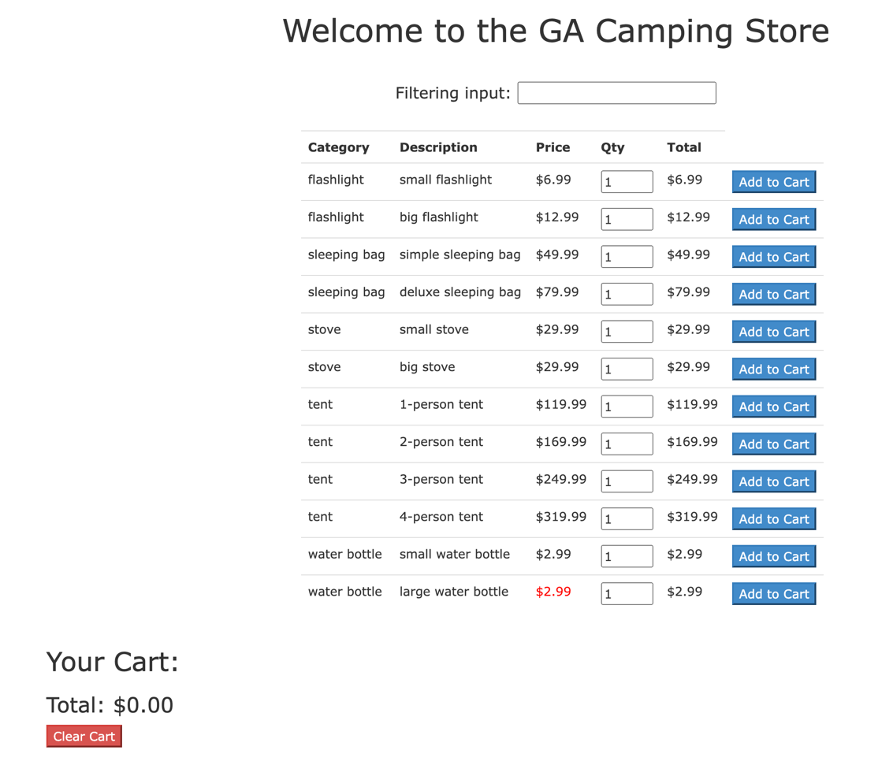

- When user input the value to filtering input, it automatic filter and show list with all values of category or description match with filter value. (3 points)

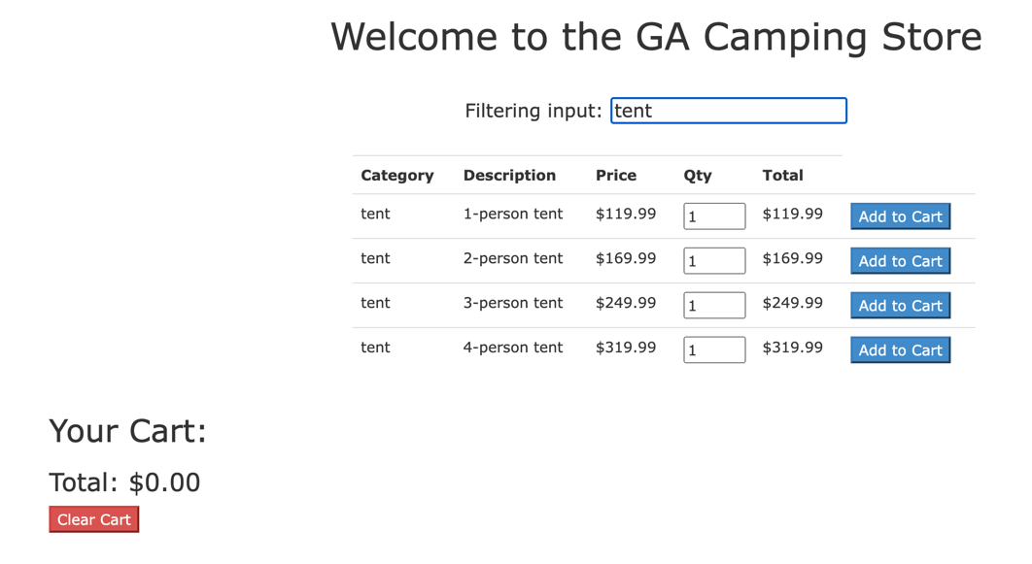

- When user click button “Add to Cart”, one item are add to Your Cart if it not exist. If item existed, it will be increate by one and calculate quantity of item multiply with price and show the total (3 points)

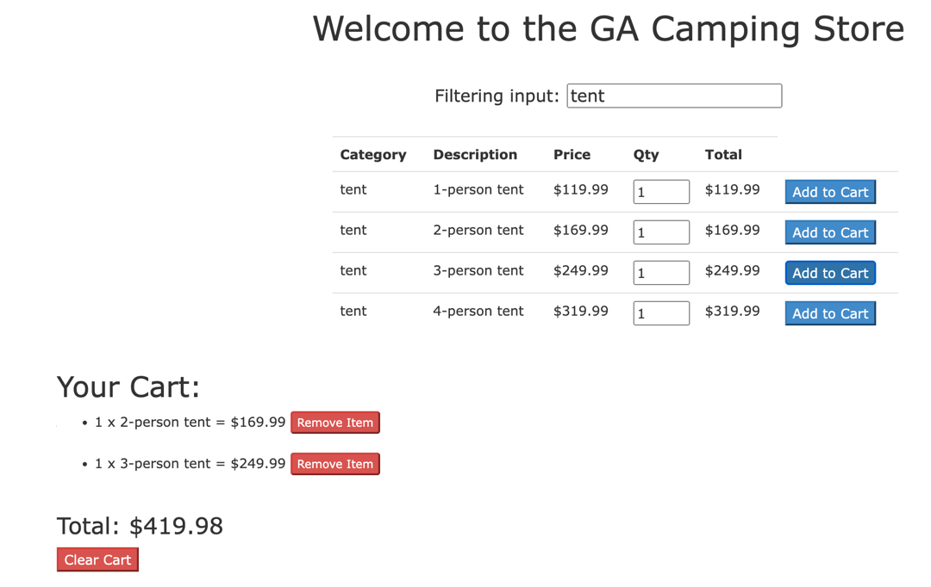

- Calculate and show total price of all items in your cart (1 point)
- When user click button “Clear Cart”, the total amount and all item in your cart will be remove (1 point)

